

SCDHHS Test Closure Report

Project Name: MCTRA

****Prepared**** by:

South Carolina Department of Health and Human Services (SCDHHS) Project Management Office (PMO)

Contents

1. Test Summary 3

1.1 Document Purpose 3

1.2 System/System Integration Test (QA/UA) 3

2. Test Items: 3

2.1.1 Summary of Test Case Execution 3

2.1.2 Variance to Plan and Associated Risk 4

2.1.3 Summary of Defects 4

2.1.4 Description of All Outstanding Defects 4

2.1.5 Exit Criteria Results (Was Exit Criteria Met or Not) 5

**Revision History**

|  |  |  |  |
| --- | --- | --- | --- |
| **Version Number** | **Revision Date** | **Summary of Changes** | **Modified by** |
| V.1 | 1/1/2018 | Initial Draft | Parth Patel |
| V.2 |  |  |  |
| V.n |  |  |  |

**Contributors**

| **Name** | **Title** |
| --- | --- |
| Parth Patel | QA Lead |
|  |  |

**Approvals**

|  |  |  |  |
| --- | --- | --- | --- |
| Signature: |  | Date: | 1/1/2017 |
| Print Name: | Janina Johnson |  |  |
| Title: | Deputy PMO Director |  |  |
| Role: | Program PMO Director |  |  |

|  |  |  |  |
| --- | --- | --- | --- |
| Signature: |  | Date: | 1/1/2017 |
| Print Name: | James Smith |  |  |
| Title: | Program Director |  |  |
| Role: | Program Director |  |  |

|  |  |  |  |
| --- | --- | --- | --- |
| Signature: |  | Date: | 1/1/2017 |
| Print Name: | Alvan Pridgeon |  |  |
| Title: | Test Manager |  |  |
| Role: | Test Manager |  |  |

|  |  |  |  |
| --- | --- | --- | --- |
| Signature: |  | Date: | 1/1/2017 |
| Print Name: | Angelia Davis |  |  |
| Title: | QA Lead |  |  |
| Role: | PMO TCOE Auditor |  |  |

# Test Summary

## Document Purpose

The purpose of this document is to provide transparency of test results once the exit criteria has been met for one or more base test phases. This document may be used as a communication mechanism when a test milestone has been completed (QA, UAT) or as a Test Summary Closure Report at the conclusion of a Project.

# System/System Integration Test (QA/UA)

## Test scope:

* Validate ICD-10 codes
* Validate HCPC codes
* Validate Change request

### Summary of Test Case Execution

|  |  |  |
| --- | --- | --- |
| **Item** | **Number** | |
| **Test cases planned/targeted for execution:** | 100 | |
| **Test Case State** | **Number** | **Percentage** |
| Passed | 85 | 85% |
| Failed | 10 | 10% |
| N/A | 5 | 5% |
|  |  |  |

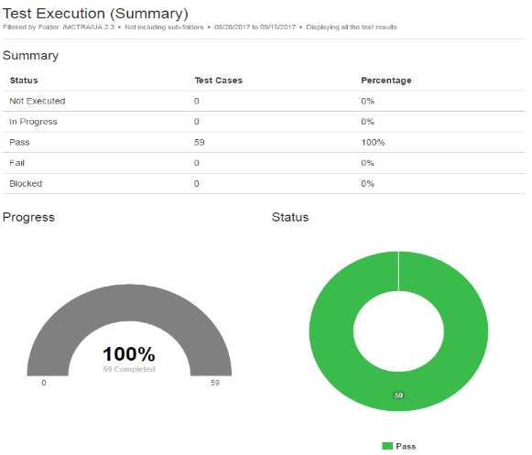

### Variance to Plan and Associated Risk/Assumptions

Delay in fixing the defect MCTRA-123 caused to extend the testing time frame for a week.

### Summary of Defects

|  |  |  |  |  |  |  |  |
| --- | --- | --- | --- | --- | --- | --- | --- |
| **All Defects, by Severity, by Status** | | | | | | | |
| **Defect Severity** | **Open** | **In Progress** | **Resolved** | **Reopened** | **Closed** | **Deferred** | **Grand Total** |
| 1-Critical | 2 | 3 | 2 | 1 | 5 | 1 | 14 |
| 2-High | 0 | 0 | 0 | 1 | 0 | 2 | 3 |
| 3-Medium | 1 | 0 | 1 | 0 | 5 | 1 | 8 |
| 4-Low | 4 | 3 | 2 | 1 | 0 | 0 | 10 |
| Grand Total | 7 | 6 | 5 | 3 | 10 | 4 | 35 |

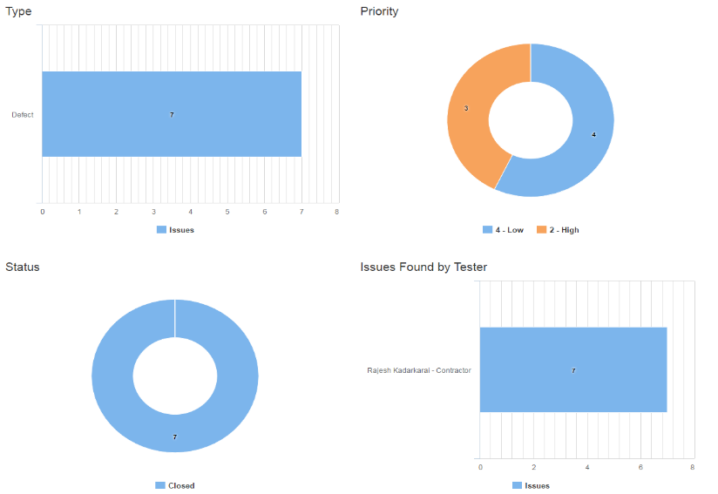

### Description of All Outstanding Defects

|  |  |  |  |
| --- | --- | --- | --- |
| **QA/UA**  **Defect ID** | **Priority** | **Brief Description of Defect** | **Resolution Plan** |
| MCTRA-123 | Medium | Change request is not working | Issue will be fixed before UAT sign off |
| MCTRA-456 | Low | HCPCS indicator value is missing | Issue will be fixed before UAT sign off |
|  |  |  |  |
|  |  |  |  |
|  |  |  |  |

### Exit Criteria Results (Was Exit Criteria Met or Not)

* Test case execution completed with 100% passed
* All defects are recorded in Quality Center or Jira
* No outstanding “showstopper or severe” defects
* All test results have been documented
* All code has been migrated into the Pre-Prod environment
* No new defects have been discovered for a week prior to System Testing.

### Coverage of code/functionality/requirements is 100% of functional requirements. Traceability Report

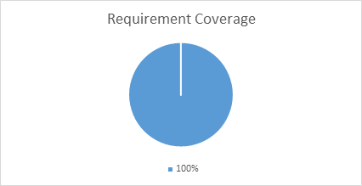

### Performance Report

**High Level Performance Test Results Summary**

Type of Test                                       : **LOAD Test**

Environment                                       : **Performance Environment 3W/7A UAT**

Period                                                 : **13/02/2016   18:52:11 - 13/02/2016   20:37:24**

Total number of users                        : **500**

Number of Transaction                       : **72,243**

Number of pass transaction               : **72,243**

Number of fail transactions                : **0**

**Transactions Response Timings**

|  |  |  |  |  |  |  |  |
| --- | --- | --- | --- | --- | --- | --- | --- |
| **Transaction Name** | **Minimum** | **Average** | **Maximum** | **Std. Deviation** | **90 Percent** | **Pass** | **Fail** |
| 01_01_OL-IC-001-To Login_01 | 0.107 | 0.819 | 21.092 | 2.872 | 1.171 | 56 | 0 |
| 01_02_OL-IC-001-Home to Establish Claim | 0.081 | 0.181 | 1.472 | 0.248 | 0.326 | 56 | 0 |
| 01_03_OL-IC-001-Apply for Benefits to Information Checklist | 0.045 | 2.364 | 113.958 | 15.068 | 0.779 | 56 | 0 |
| 01_04_OL-IC-001-Information Checklist to Data Privacy Authorization | 0.412 | 1.532 | 6.331 | 1.512 | 4.682 | 56 | 0 |

### Final Recommendation

Identified requirements have been validated in QA environment. Results are captured in Jira/ Adaptavist Test management tool. TcoE recommend to promote into UAT.